ssh jimi@167.172.144.11 pass: hendrix

ls /etc

cat /etc/packetcaptureinfo.txt

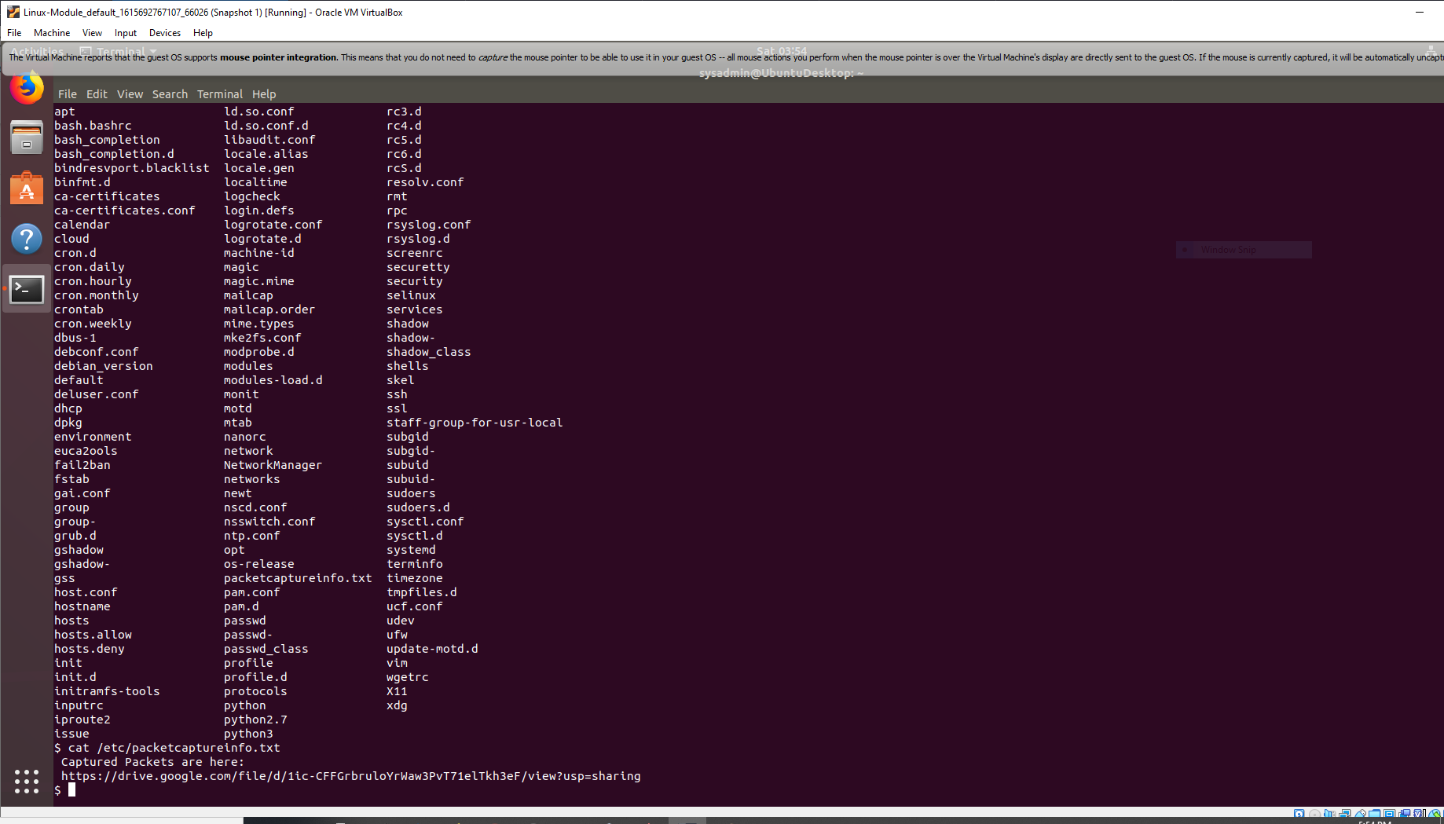

<https://drive.google.com/file/d/1ic-CFFGrbruloYrWaw3PvT71elTkh3eF/view?usp=sharing>

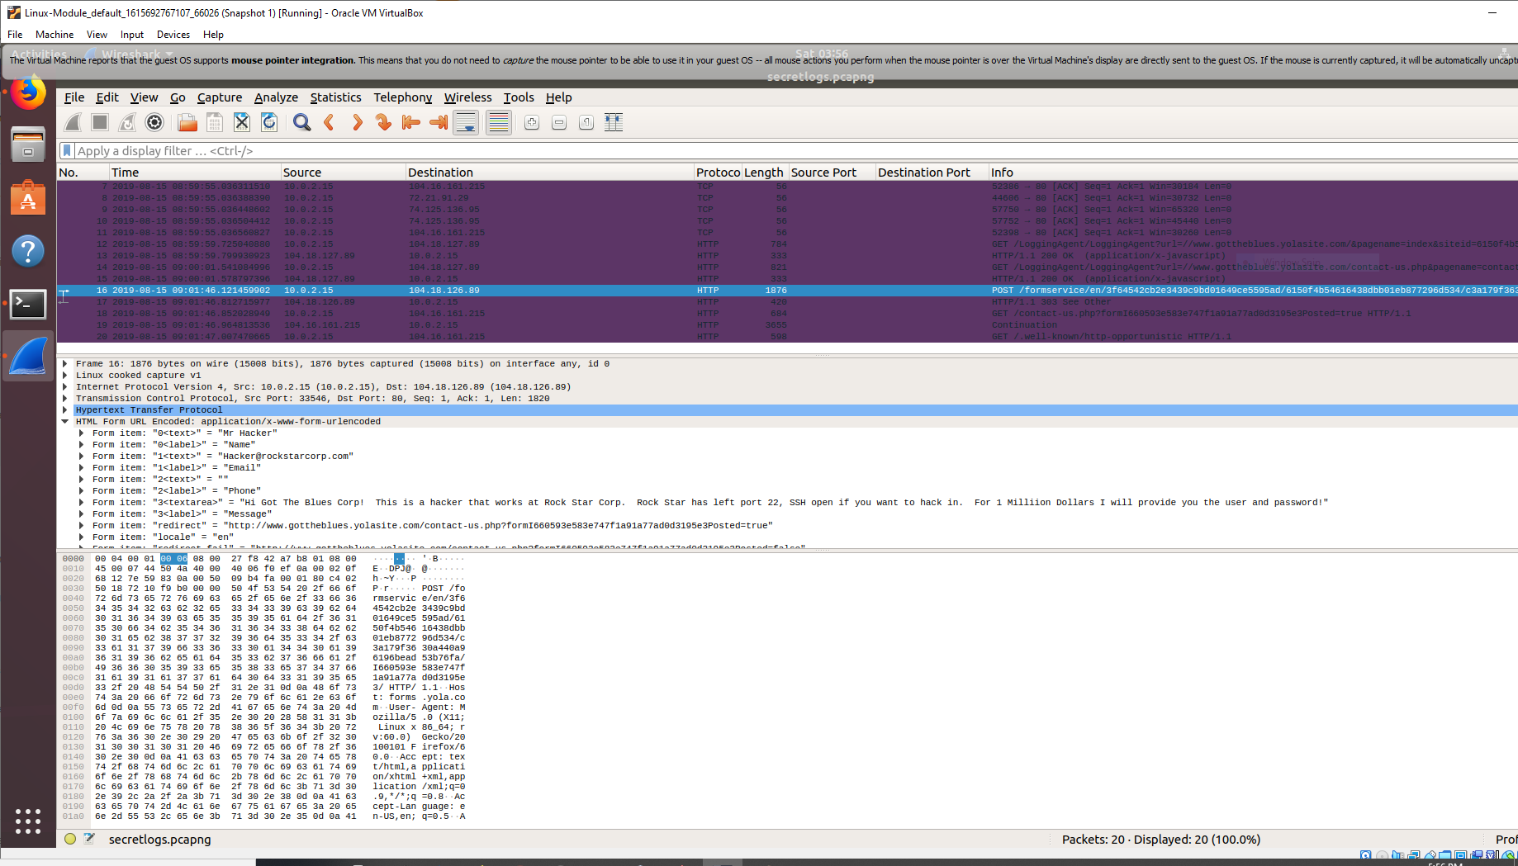

Hacker used source address 10.0.2.15 and destination ip address is 104.18.126.89

POST /formservice/en/3f64542cb2e3439c9bd01649ce5595ad/6150f4b54616438dbb01eb877296d534/c3a179f3630a440a96196bead53b76fa/I660593e583e747f1a91a77ad0d3195e3/ HTTP/1.1

Hacker has MAC address of 00:0c:29:1d:b3:b1